Puzzle - Digital Light Sensor

Introduction
This module is based on the I2C light-to-digital converter TSL2561 to transform light intensity to a digital signal. Different from traditional analog light sensor, as Puzzle - Light Sensor, this digital module features a selectable light spectrum range due to its dual light sensitive diodes: infrared and full spectrum.
You can switch among three detection modes to take your readings. They are infrared mode, full spectrum and human visible mode. When running under the human visible mode, this sensor will give you readings just close to your eye feelings.

Features
- Selectable detection modes
- High resolution 16-Bit digital output at 400 kHz I2C Fast-Mode
- Wide dynamic range: 0.1 - 40,000 LUX
- Wide operating temperature range: -40°C to 85°C
- Programmable interrupt function with User-Defined Upper and lower threshold settings

Specifications
Items | Min Type Max | Unit
Supply voltage, VDD | 3.3 5 5.1 | V
Operating temperature | -30 \ 70 | ℃
SCL,SDA input low voltage | -0.5 \ 0.8 | V
SCL,SDA input high voltage | 2.3 \ 5.1 | V

Usage
Plug the Puzzle - Digital Light Sensor onto the I2C port on Puzzle - Base Shield, and then plug the base shield onto Arduino;

2. Download the library file:Digital Light Sensor Library;
3. Unzip it into the libraries file of Arduino IDE by the path: ..\arduino-1.0.1\libraries.
4. Create an Arduino sketch and paste the following codes to it or open the code directly by the path:File -> Example ->Digital_Light_Sensor->Digital_Light_Sensor.

/* Digital Light sensor demo V1.0
* Connect the sensor to I2C port of Arduino to use.*/

#include <Wire.h>
#include <Digital_Light_TSL2561.h>
void setup()
{
Wire.begin();
Serial.begin(9600);
TSL2561.init();
}

void loop()
{
unsigned long Lux;
TSL2561.getLux();
Serial.print("The Light value is: ");
Serial.println(TSL2561.calculateLux(0,0,1));
delay(1000);
}
- Upload the code. Please click here if you do not know how to upload.
6. Open the serial monitor to see the result.

Reference
Register Map
The TSL2561 is controlled and monitored by sixteen registers (three are reserved) and a command register accessed through the serial interface. These registers provide for a variety of control functions and can be read to determine results of the ADC conversions. The register set is summarized as show below.
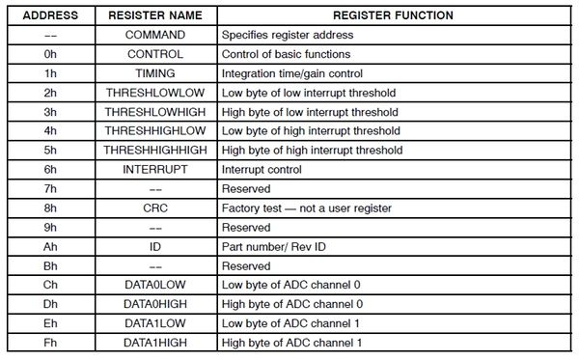
Spectrum Response Curve
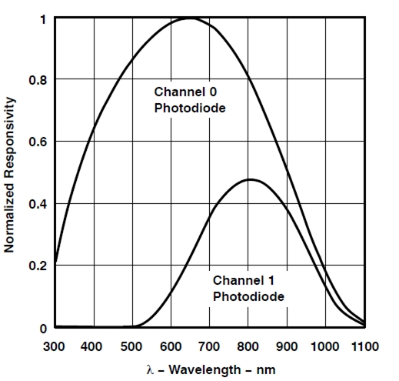
Resource
Puzzle - Digital Light Sensor Eagle File
Puzzle - Digital Light Sensor Schematic
CalculateLux Library File
TSL2561 Datasheet

